**Experiment 28**

**Lab Book:**

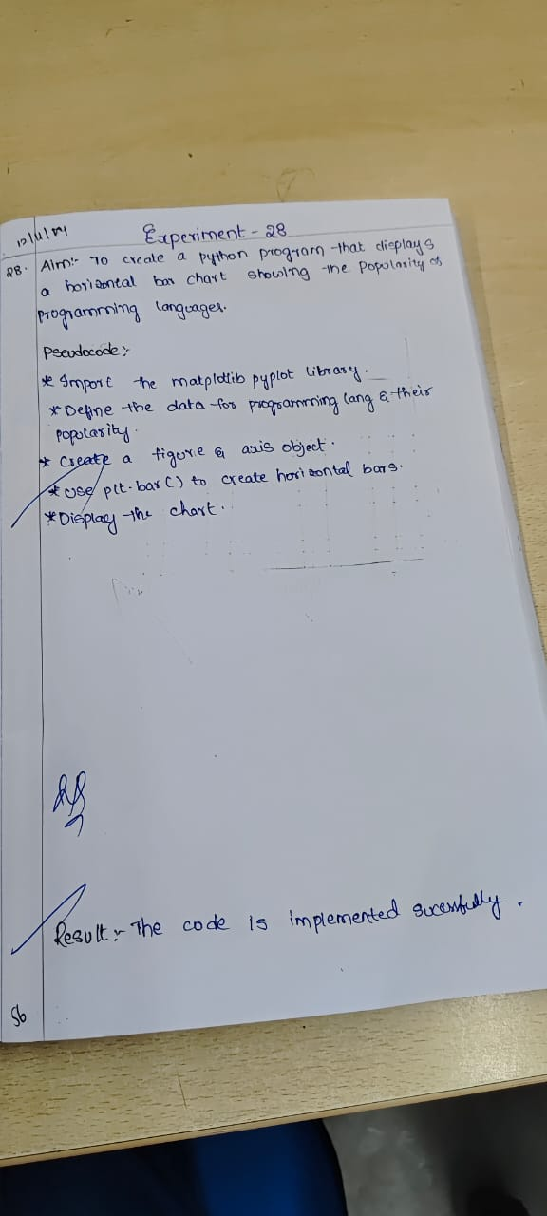

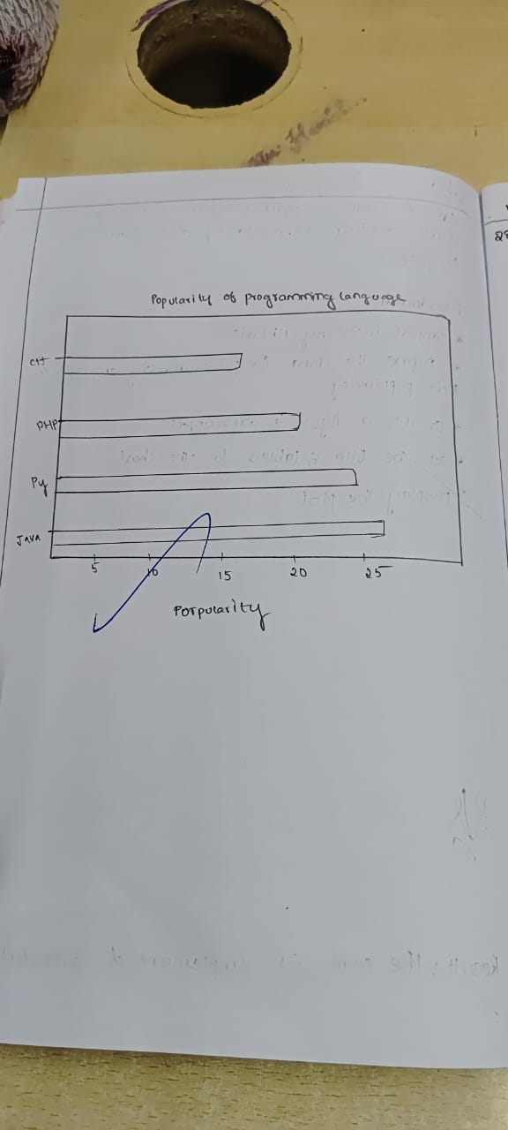

**Code**

import matplotlib.pyplot as plt

languages = ['Java', 'Python', 'PHP', 'JavaScript', 'C#', 'C++']

popularity = [22.2, 17.6, 8.8, 8, 7.7, 6.7]

colors = ['blue', 'green', 'red', 'purple', 'orange', 'cyan']

plt.barh(languages, popularity, color=colors)

plt.xlabel('Popularity (%)')

plt.ylabel('Programming Languages')

plt.title('Popularity of Programming Languages')

plt.show()

**Sample Output**

